**FAISAL** **A RAMADHAN**

RESUME

L:\Graphicriver\+Resumes\UnderWork\New CV\Assets\icon-mobile.pngL:\Graphicriver\+Resumes\UnderWork\New CV\Assets\icon-address.pngL:\Graphicriver\+Resumes\UnderWork\New CV\Assets\icon-email.pngicon-blue.pngicon-blue.pngicon-blue.pngs

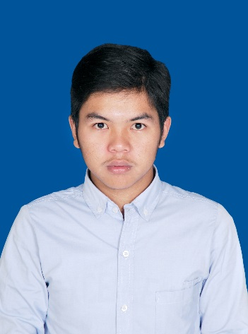

Saya Seseorang muslim yang mau belajar, disiplin, dapat berkomunikasi dengan baik dengan orang lain/team memiliki dan loyalitas terhadap pekerjaan.

2014 - 2018

college student informatic engineering at POLYTECHNIC pos of indonesia

**Cost Engineering at PT. Pos Indonesia**

**Facebook**facebook.com/faisalakbar(bob)

**Twitter** twitter.com/faisalakbarrrrr **instagram**Fakbarr

**cONTACT ME**

**Powerpoint**

**word**

**follow me**

+6282112892406

faisalakbarrrrr@gmail.com

**Education**

**skills**

**experience**

Okt2019 - Now

Agu2017 – Feb2018

**Profile**

**excel**

2012 - 2014

STUDENT AT SMA PASUNDAN 8 WEST JAVA

**Wadir III Student Affairs and Alumnae/Cooperation**

Bandung, Cidadap Girang No.48

Kec.Cidadap 40141